CXBanking

OptiVLM Vault Balance 10.1

User Reference Guide

**Build 5013**

**Version 10.1**

**April 2023**

Copyright and Trademark Information

If this guide is distributed with software that includes an end-user agreement, this guide, as well as the software described in it, is furnished under license, and may be used or copied only in accordance with the terms of such license. Except as permitted by any such license, no part of this guide may be reproduced, stored in a retrieval system, or transmitted, in any form or by any means, electronic, mechanical, recording, or otherwise, without the prior written permission of NCR Incorporated. Please note that the content in this guide is protected under copyright law even if it is not distributed with software that includes an end-user license agreement.

The content of this guide is furnished for informational use only, is subject to change without notice, and should not be construed as a commitment by NCR Incorporated. NCR Incorporated assumes no responsibility or liability for any errors or inaccuracies that may appear in the informational content contained in this guide.

OptiCash, OptiNet, OptiVault, OptiCashMI, OptiVLM, OptimizeCF, OptiSuite, OptiRecon, and OptiBridge are trademarks of NCR International Inc.

Adobe Acrobat Reader is a registered trademark of Adobe Systems Incorporated. Microsoft, Windows, and Windows Vista, Internet Explorer (IE) are either registered trademarks or trademarks of Microsoft Corporation in the United States and/or other countries. Solaris is a Trademark or registered trademark of Sun Microsystems, Inc. in the United States and other countries. Oracle is a trademark of Oracle in the United States and other countries. WebSphere is a trademark of IBM in the United States and other countries. UNIX is a trademark in the United States and other countries, licensed exclusively through X/Open Company, Ltd. All other trademarks are the property of their respective owners.

Revision Record

|  |  |  |
| --- | --- | --- |
| Date | Page No. | Description of Change |
| March2023 | ALL | Formatting Changes |
| April 2023 |  | 10.1 |
|  |  |  |

Contents

Copyright and Trademark Information 2

Revision Record 3

Contents 4

CONVENTIONS USED IN THIS HELP DOCUMENTATION 6

1 INTRODUCTION TO VAULT BALANCE 7

1.1 GETTING STARTED 7

1.1.1 SCREEN RESOLUTION 7

1.1.2 NAVIGATION TIPS 8

1.1.3 ACCESSING VAULT BALANCE 8

1.1.4 OPENING VAULT BALANCE 8

1.1.5 LOGGING OUT OF EPSS 9

1.2 INTERFACE OVERVIEW 10

1.2.1 MAIN MENU TABS 10

1.2.2 COMMON VAULT BALANCE ICONS AND BUTTONS 11

1.2.3 DATE SELECTOR 12

2 DASHBOARD 13

2.1 QUICK ADJUST 14

2.2 BALANCE ADJUSTMENT 15

3 Coffer and Qualities 17

3.1 VAULT DETAILS 17

3.2 VAULT SETTINGS 19

3.3 PROCESS CASH BY QUALITY OR COFFER 19

3.4 FORCE-CLOSE 20

3.5 CASH QUALITIES 21

3.5.1 CREATE NEW QUALITIES 23

3.6 CASH QUALITY MAP 23

3.6.1 CREATE NEW CASH QUALITY 24

3.7 COFFERS 25

3.7.1 CREATE NEW COFFER 26

3.8 BALANCE ACTION MAP 26

3.8.1 CREATE A NEW BALANCE ACTION MAP ENTRY 28

4 Logs 30

4.1 SYSTEM EVENT LOG 30

4.1.1 TRANSACTIONS LIST 31

4.1.2 SHOW OPTI ORDER SCREEN 34

4.1.3 BALANCE HISTORY 36

5 SETTINGS 38

5.1 VAULTS 40

5.1.1 CREATE NEW VAULTS 41

5.2 MASTER COFFERS 42

5.2.1 USERS 42

5.3 CURRENCIES 44

5.3.1 CREATE NEW CURRENCIES 44

5.4 DENOMINATIONS 45

5.4.1 CREATE NEW DENOMINATIONS 46

5.4.2 MASTER COFFER 46

5.5 APPLICATION SETTINGS 47

6 DATABASE UPGRADES 49

7 ALERTS 50

7.1 ACTIVE ALERTS 50

7.2 ALERTS HISTORY 51

CONVENTIONS USED IN THIS HELP DOCUMENTATION

The conventions used in this help documentation are shown in the table below.

Introductory information, e.g. what the doc is about, its audience, prerequisites

TABLE 1: CONVENTIONS

|  |  |
| --- | --- |
| Convention | Use |
| Green Text | Indicates a link to the top of the current section. These links can be clicked to quickly navigate through this document. (In some cases, you may need to hold the CTRL key to click the link) |
| Blue Text | Indicates a link to a different topic or section. These links can be clicked to quickly navigate through this document. (In some cases, you may need to hold the CTRL key to click the link) |
| →  | The “arrow” sign indicates a menu choice. **For example**, "***Choose File*** *→* ***Open***" means "click the File menu, and then click Open." |
|  | Used to warn users of potential problems or to take caution when making changes to settings and parameters. |
|  | Tips or information that may help use the functionality. |

# INTRODUCTION TO VAULT BALANCE

OptiVLM (Vault Logistics Management) is a multi-module solution. See TABLE 2: OPTIVLM MODULES. OptiVLM integrates with OptiSuite (OptiCash, OptiNet, and OptiVault) data to provide multi-user access to real-time updated information regarding currency inventory and orders as they move between financial institutions, central banks or other cash sources, and armoured car networks.

TABLE 2: OPTIVLM MODULES

|  |  |
| --- | --- |
| Module | Description |
| **Invoice Validation** | Compares invoices related to cash transportation activities with activity records from OptiSuite. Invoice Validation searches for discrepancies in services rendered, amounts transported, and applied billing rates. |
| **Carrier Web** | Provides an interface for carriers (armoured car vendors) to access and update order status. Carrier Web also provides branches access to information regarding authorized carrier personnel. |
| **Vault Balance** | Utilizing OptiSuite activity, Vault Balance provides real-time updates for your vaults’ balances and activity. |

OptiVLM is hosted and managed by the financial institution, but the different modules may be accessed and operated by external users including the vaults and armoured car vendors.

**This User Guide is concerned with the Vault Balance module. For user information relative to the Invoice Validation or the Carrier Web interfaces, please refer to the respective guides.**

|  |  |
| --- | --- |
|  | **Caution**: OptiVLM is a live application. Changes that are made in the application are permanent and can affect the operation of the system. There are limited undo capabilities for the users; therefore, be sure to consult this manual before deleting or changing system parameters. |

## GETTING STARTED

Vault Balance is a web-based application that automatically updates itself in real-time based on OptiSuite activity. As currency moves among the various cashpoints (ATMs, Branches, Vaults), Vault Balance will reflect the real-time activity.

### SCREEN RESOLUTION

Because OptiVLM runs in a browser, the user may choose any valid desktop resolution, and OptiVLM will resize automatically. 1024x768 resolution and larger is recommended to minimize scrolling on some of the screens containing large amounts of information.

### NAVIGATION TIPS

When using OptiVLM, avoid using the Back and Forward buttons  in the browser. All navigation should occur within the application via the menu or icons thereby insuring the successful processing of the OptiVLM system.

### ACCESSING VAULT BALANCE

To start using the application, first type in the required EPSS ApplicationOptiVLM URL into your browser and then proceed to access Vault Balance with provided user ID and password. Make sure to correctly enter the credentials as more than five(5) incorrect attempts will block your account. If you don’t have user ID and password please contact your administrator.   
  
Users can be added from Shared Services > User Management by admin.

|  |  |
| --- | --- |
|  | **Suggestion**: Save the EPSS ApplicationURL in the Favorites folder for easier future access. |

### OPENING VAULT BALANCE

EPSS Application will launch within the browser. Security is supplied through external authentication via your systems network logon. If you are not already logged in via network authentication you will be prompted for a username and password. To log in, enter your Username and Password and click Login.

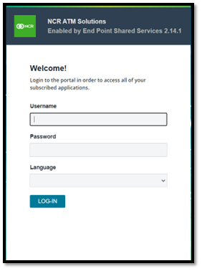

After a successful login, you will be directed to the Cash Management Dashboard screen, as depicted below. To enter VaultBalance, click on the 'VB' button located in the App Launcher. App launcher is the icon at top left of the screen which allows users to switch between the application to which user has access to.   
  
Note: If you don’t see the desired application which you are trying to access rech out to your administrator so the access can be provisioned.

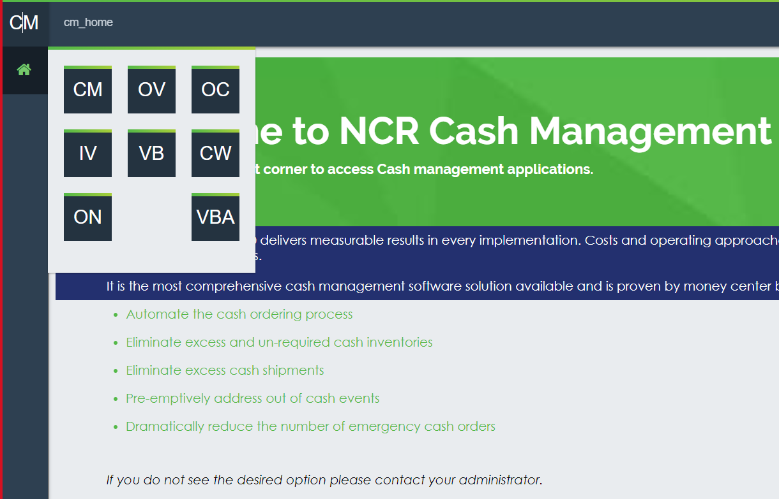



### LOGGING OUT OF EPSS

Users can log out by either closing the browser or using an external authentication method. Alternatively, users can click on the Logout button found in the User Menu Item Icon situated among the menu options on the lower left-hand side of the screen.

## INTERFACE OVERVIEW

The following section will provide examples of the Vault Balance interface pages, functionality, purpose, and/or use of each page. This section is a reference when working with the application on a daily basis.

In order to keep this manual as succinct as possible, This section provides a detailed description of the user interface. Other chapters throughout the manual will then refer to the appropriate section of the user interface to avoid having duplicate screen images and text.

This chapter has been broken out into different sections to make it easier for readers to find the information they are seeking. The General topics are broken into the main Tabs or functions with all associated information under those sections.

Below is an overview of the information that will be discussed, along with hyperlinks to each topic.

Main Menu Tabs

Common Vault Balance Icons and Buttons

Date Selector

### MAIN MENU TABS

The user can control Vault Balance operations through the main menu tabs as shown in FIGURE 1: MAIN MENU TABS. After selecting the menu items, additional options are displayed, until a final menu option is reached, allowing full access to all functions.

FIGURE 1: MAIN MENU TABS

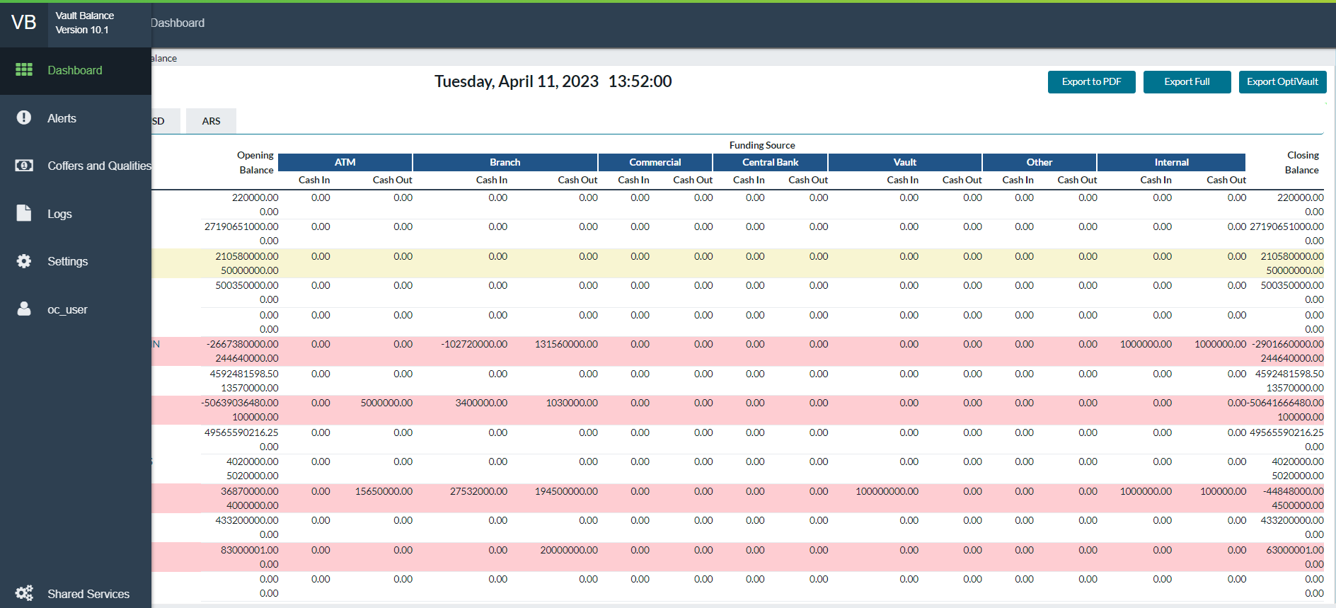

Return to: Interface Overview

TABLE 3: MAIN MENU TABS

|  |  |
| --- | --- |
| Tabs | Description |
| **Dashboard** | Shows all Vaults with current cash status/movement for each funding source (ATM, Branch, Commercial, Central Bank, Vaults, Other and Internal Funding Source). Each vault listing is hyperlinked to access details by denomination type and quality. |
| **Settings** | Accesses the parameters and settings associated with Vault Balance. Available to Admin users only. |
| **Alerts** | Links to listings for both Active and Historical alerts. |
| **Coffers and Qualities** | The Coffer functionality enables users to group cash based on the mapping of workflow and quality, for example, a two-way mapping of ATM Replace Cash/Fit quality, resulting in the creation of a coffer. |
| **Logs** | Log provides access to tracking system events |
| **Logged in as:** | Shows the User ID presently logged in. |

Return to: Interface Overview

### COMMON VAULT BALANCE ICONS AND BUTTONS

Some common icons and buttons are used throughout the application with which the user should become familiar. Table 4: OptiVLM-Vault Balance Icons gives an overview of these icons and their functions.

TABLE 4: OPTIVLM-VAULT BALANCE ICONS

| Icon | Description |
| --- | --- |
|  | **New Icon:** Add a new record. |
|  | **View Icon:** View a specific record. |
|  | **Update Icon:** Update a specific record. |
|  | **Delete Icon:** Delete the associated record. |
|  | **Return to:** Returns the User to the previous screen |
|  | **Write to/Enter:** This takes the user to the Balance Entry screen. |
|  | **Delete:**  Delete Record or item |
|  | **Export to CSV:** Exports screen contents to a .csv report for external analysis |
|  | **Export to PDF:** Exports screen contents to a .pdf report for external analysis |
|  | Select the **English** language |
|  | Select the **Spanish** Language |
|  | Select the **Thai** Language |
|  | **Save**: Allows changes made on the screen to be permanently saved to the appropriate file |

Return to: Interface Overview

### DATE SELECTOR

In several areas of the application, it may be necessary to select or change a date for reports, orders, etc. The Date Selector is located under *Settings -> Logs -> System Event Logs*. The **To** and **From** **Date** fields use the Date Selectors.

FIGURE 2: DATE SELECTOR

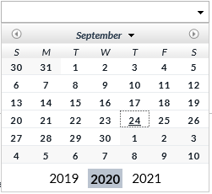

Return to: Interface Overview

TABLE 5: DATE SELECTOR DESCRIPTION

|  |  |
| --- | --- |
| Field | Description |
|  | Moves the Calendar 1 month forward or backward |
| **Dates** | Selects the date of the month to be searched for |
| **Years** | Specifies the year to be searched |

# DASHBOARD

The Dashboard provides a real-time summary of all cash flows to and from the different sources for each vault. From the Dashboard, the user can hyperlink to individual vaults to access detailed information. Users can also export to file (CSV) for detailed analysis or report generation.

FIGURE 3: DASHBOARD SCREEN

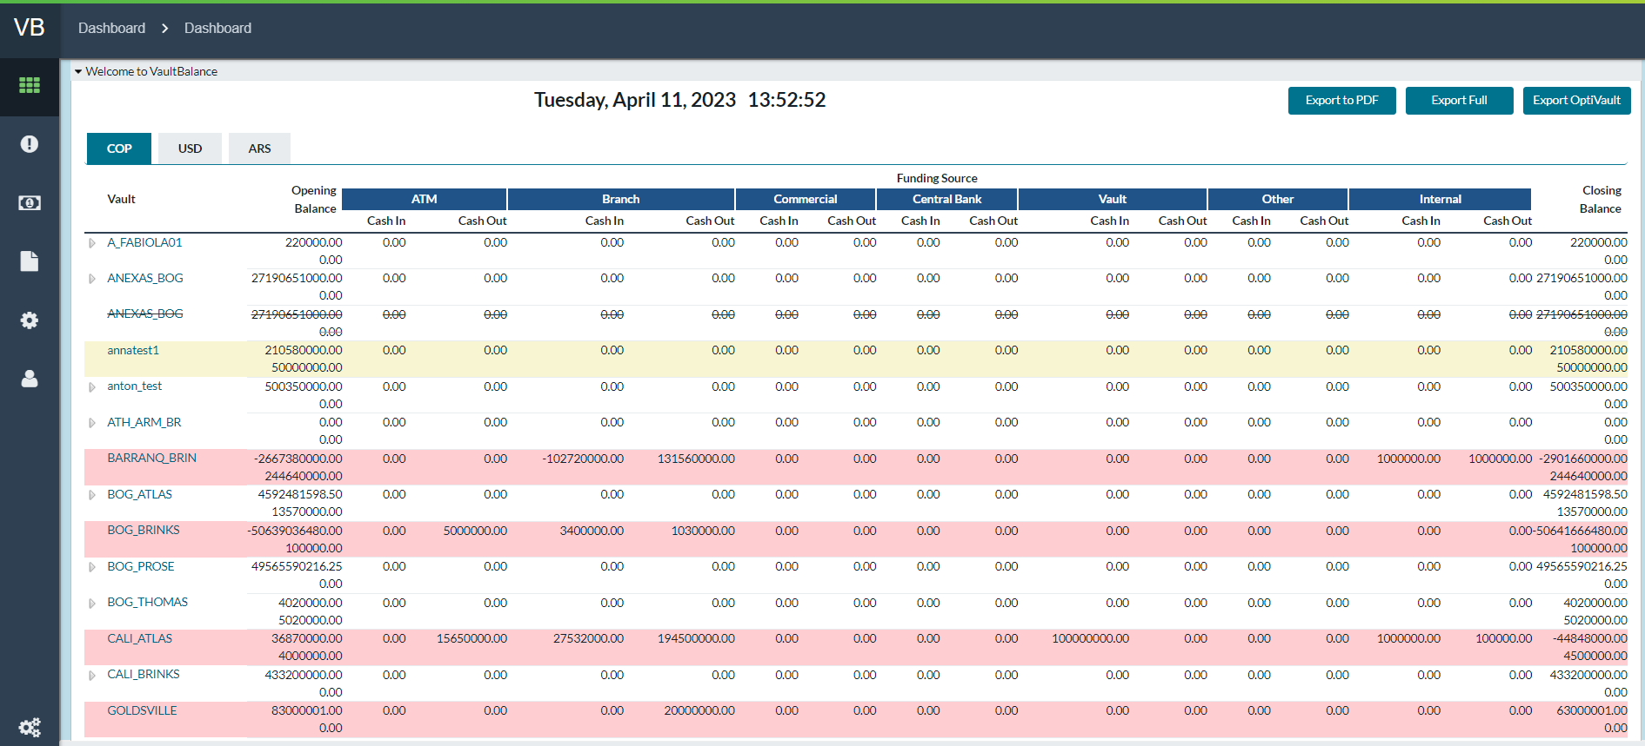

Return to: Dashboard

TABLE 6: DASHBOARD FIELD DESCRIPTIONS

|  |  |
| --- | --- |
| Field | Description |
| **Date** | Reflects current Day, Month, Year, and Time for transaction status |
| **Currency Tabs** | An individual tab for each currency utilized in the different vaults will be displayed. Users can navigate by clicking on each tab. |
| **Vault** | The hyperlinked ID of all Vaults to which the user has access. Hyperlink takes the user to the **Vault Details** screen where the user can view detailed balance and transaction amounts. |
| **Opening Balance** | Vault total Opening Balance for the period. When a vault is closed, its verified closing balance becomes the opening balance of the next period. |
| **Funding Source** | Currency travelling In/Out of each vault from/to the different source types.   * ATM * Branch * Commercial Customers * Central Bank * Vaults * Other * Internal Adjustments |
| **Closing Balance** | Vaults projected Closing Balance based upon Opening Balance plus or minus all ongoing currency movement |
| **Export Full** | Exports balance information for all vaults to a file. |
| **Export OptiVault** | Exports balance information to a file that matches OptiVault input format. |
| **Export to PDF** | Exports screen contents to a .pdf report for external analysis |
| **Denomination**  **(Vault Details only)** | Shows the currency denomination (note or coin) that the detail relates to. **Examples**: $100 notes, 10 Euro notes, 50 Peso coins, etc. |
| **Quality (Vault Details only)** | Shows the note quality the detail relates to. (Fit, Unknown, Normal, and Soiled for example) |

Return to: Dashboard

## QUICK ADJUST

OptiVLM Vault Balance operates by taking a beginning balance and updating that as system updates occur. Occasionally, this balance may become out of sync with real-world cash position and then the users will update the balance in OptiVLM Vault Balance. The Quick Adjustment page is used to accomplish this for coffer balances in “**Internal**” or “**Ignored**” coffers (those not part of the primary balance totals).

**Note**: This page may be enabled or disabled by your administrator.

FIGURE 4: QUICK ADJUST SCREEN

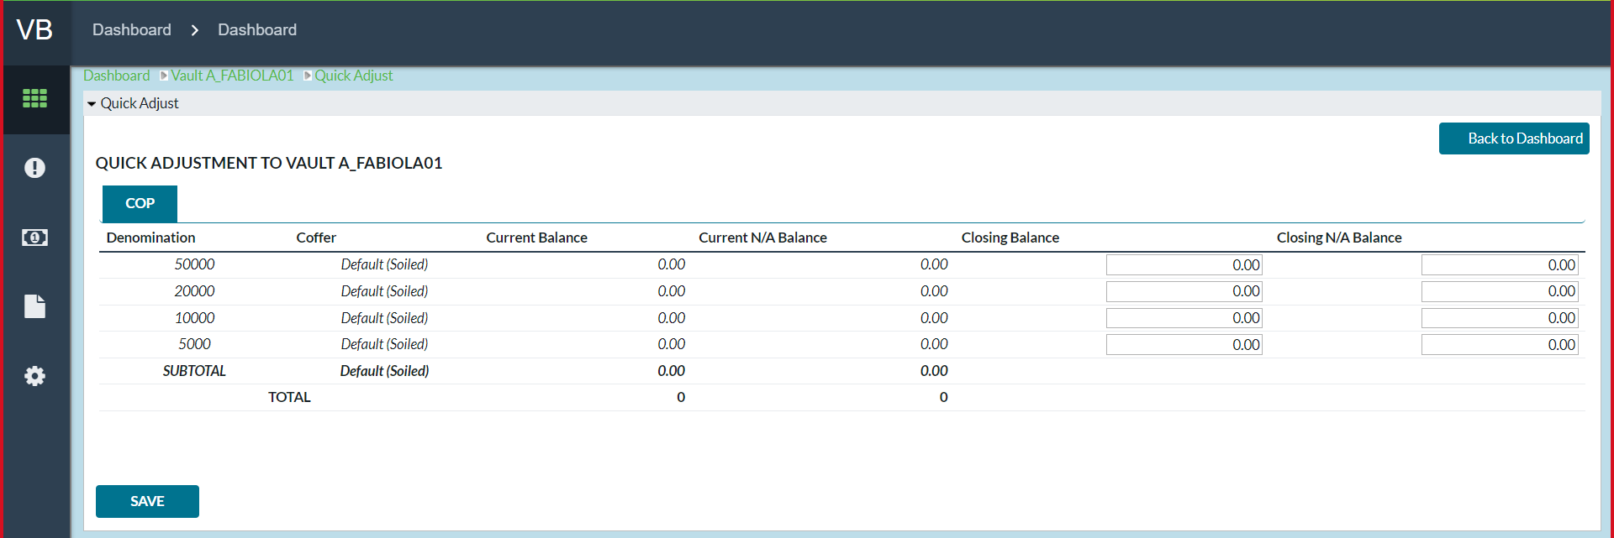

TABLE 7: QUICK ADJUST FIELD DESCRIPTION

|  |  |
| --- | --- |
| Field | Description |
| **Denomination** | Shows the currency denomination (note or coin) that the detail relates to. **Examples**: $100 notes, 10 Euro notes, 50 Peso coins, etc. |
| **Coffer** | Coffer and quality for this record. |
| **Current Balance** | Current Balance by Denomination and Coffer |
| **Current N/A Balance** | Not Available Current Balance by Denomination and Coffer |
| **Closing Balance** | New Balance by Denomination and Coffer |
| **Closing N/A Balance** | New Not Available Balance by Denomination and Coffer |

## BALANCE ADJUSTMENT

OptiVLM Vault Balance operates by taking a beginning balance and updating that as system updates occur. Occasionally, this balance may become out of sync with real-world cash position and then the users will update the balance in OptiVLM Vault Balance. The Balance Adjustment page is used to update a single detail balance.

**Note**: This page may be enabled or disabled by your administrator.

FIGURE 5: BALANCE ADJUSTMENT SCREEN

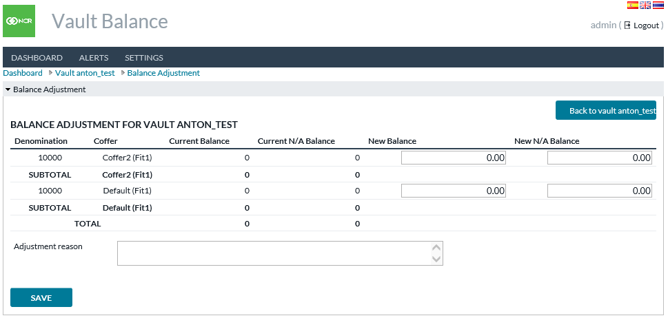

TABLE 8: BALANCE ADJUSTMENT FIELD DESCRIPTION

|  |  |
| --- | --- |
| Field | Description |
| **Denomination** | Shows the currency denomination (note or coin) that the detail relates to. Examples: $100 notes, 10 Euro notes, 50 Peso coins, etc. |
| **Coffer** | Coffer and quality for this record. |
| **Current Balance** | Current Balance by Denomination and Coffer |
| **Current N/A Balance** | Not Available Current Balance by Denomination and Coffer |
| **New Balance** | New adjusted balance value entered by the user |
| **New N/A Balance** | Not Available New adjusted balance value entered by the user |

# Coffer and Qualities

Coffer functionality allows users to create groupings of cash based on mapping of workflow and quality such as **ATM Replace Cash/Fit** quality would be two-way mapping thus creating a coffer. Coffers run parallel to the default Dashboard, but it reflects balances by the various coffers as opposed to the Funding Source breakdown reflected on the default Dashboard.

Users can create as many coffers as required, and they can designate a coffer as the default coffer. By mapping coffers to a combination of a workflow and a quality, it guarantees once a new order comes into Vault Balance the related Coffer Balance can be updated at the same time by following the workflow/quality mapping.

TABLE 9: COFFER DASHBOARD FIELD DESCRIPTIONS

|  |  |
| --- | --- |
| Field | Description |
| **Date** | Reflects current Day, Month, Year, and Time for transaction status |
| **Currency Tabs** | An individual tab for each currency utilized in the different vaults will be displayed. Users can navigate by clicking on each tab. |
| **Vault** | The hyperlinked ID of all vaults to which the user has access. Hyperlink takes the user to the **Vault Details** screen where the user can view detailed balance and transaction amounts. |
| **Total** | Vault total Opening Balance for the period. When a vault is closed, its verified closing balance becomes the opening balance of the next period. |
| **Coffer Tabs** | Vault Balance comes with the “**Default**” coffer in which all amounts will flow unless mapped to new coffers setup by users. Displayed examples of other coffers are “**ATM**”, “**Commercial**”, and “**Vault Return**” |

Return To: Coffer and Qualities

## VAULT DETAILS

Vault Details provides the same detail as the Dashboard screen in terms of cash movement and funding sources. Vault Details also provides pertinent detail regarding cash movement and funding sources at the Denomination and Quality level. For field, descriptions See: TABLE 6: DASHBOARD FIELD DESCRIPTIONS

FIGURE 6: VAULT DETAILS SCREEN



Return To: Coffer and Qualities

TABLE 10: VAULT DETAILS ICON MENU

| **Icon** | **Name** | **Description** |
| --- | --- | --- |
|  | **RETURN TO DASHBOARD** | Links user back to main **Dashboard** screen |
|  | **VAULT SETTINGS** | Links user to **Vault Settings** screen. See: Vault Settings |
|  | **ALERT HISTORY** | Links to **Alert History** screen. Alerts are filtered by the appropriate Vault ID. See Alert History. |
|  | **BALANCE HISTORY** | Links to the filtered listing of **Closing Balances** sorted by date. See The Balance History section. |
|  | **PROCESS CASH** | Links to **Process Cash** screen. See: The Process Cash screen |
|  | **FORCE-CLOSE** | Links to screen for the user to enter **Closing Balances** by denomination and close the vault manually. See the Force-Close screen |
|  | **EXPORT TO PDF** | This generates the contents of the **Vault Details** to generate the Vault Balance report in PDF format |
|  | **COFFER BALANCE** | Links to the Coffer Balance page for the Vault. |
|  | **MASTER COFFER BALANCE** | Opens the **Master Coffer Balance** report of the vault by Master Coffer and Currency/Denomination |
|  | **VAULT LOG** | Links to a page that displays the history of actions taken on the Vault. (i.e. Force closes, balance adjustments, etc.) |

Return To: Coffer and Qualities

## VAULT SETTINGS

Vault Settings allows Users to schedule automated **Closing Times** for a vault by day of the week. On the selected day and time, OptiVLM will attempt to close the vault automatically. Unresolved alerts (common error states – for example balance less than zero) would prevent the vault close. Any activity transpiring after the saved time would count towards the following balance period.

FIGURE 10: VAULT SETTINGS SCREEN

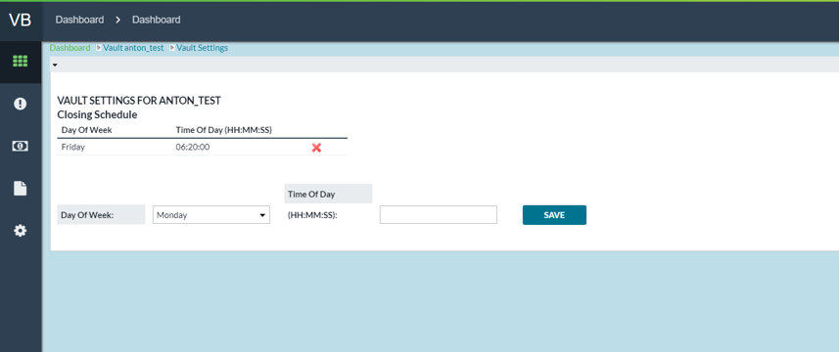

Return To:Coffer and Qualities

TABLE 13: VAULT SETTINGS FIELD DESCRIPTIONS

|  |  |
| --- | --- |
| Field | Description |
| **Day of Week** | Preformatted dropdown where User can select Monday - Sunday |
| **Time of Day (HH:MM:SS)** | Input field for the user to enter **Closing time** for the selected Day of the Week. Format of time must be HH:MM:SS |

Return To: Coffer and Qualities

## PROCESS CASH BY QUALITY OR COFFER

Process Cash function allows users to manually change amounts from one denomination and quality to a different denomination and quality. Usually, this is due to internal vault actions which would not be reflected in the Order record.

**For example,** if a container comes into the vault with mixed denominations or varying qualities, subsequently, once the cash has been sorted, it can be entered here as the resulting amounts per quality and denomination. Cash can be processed from denomination/coffer combinations to others.

FIGURE 12: PROCESS CASH

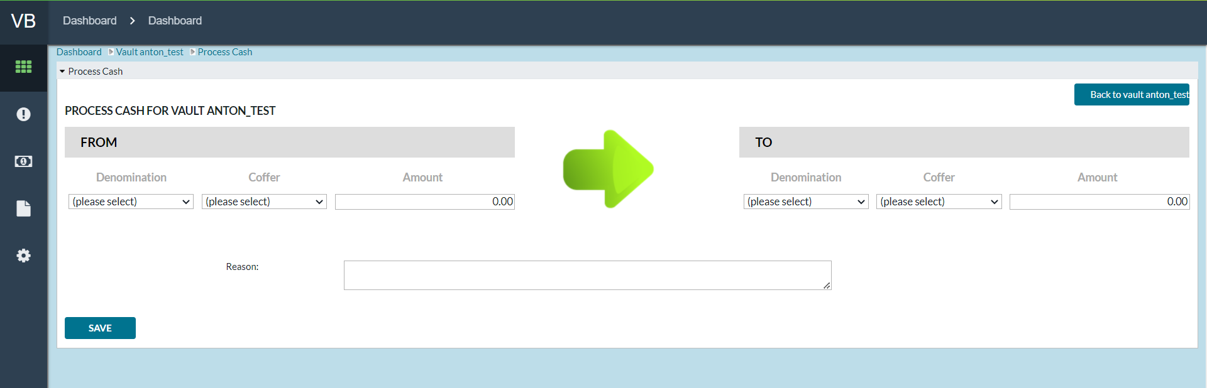

*Return To: Coffer and Qualities*

TABLE 14: PROCESS CASH FIELD DESCRIPTIONS

|  |  |
| --- | --- |
| Field | Description |
| **Denomination**  **(From and To)** | Users select from the pre-populated dropdown of all available denominations |
| **Coffer (From and To)** | Users select from the dropdown to designate both the **TO** and the **FROM** coffers utilized in the processing of cash. |
| **Amount**  **(From and To)** | User inputs desired amount |
| **Reset Values (From and To)** | Removes all input values and selections and allows the user to begin again. |
| **Reason** | A text box where the user can enter the reason for processing the Cash. It is then stored in the Vault Log. |

Return To: Coffer and Qualities

## FORCE-CLOSE

Force-Close allows users to enter detailed balances for the vault to be closed. These balances will override the current balances. Balances and activity will be archived and a new period is opened with these as the new Opening Balance. Balances entered here are assumed to be fully verified and are not intended to be modified later in any way (instead adjustments would be made to the current balance if necessary). Force Close allows users to close the vault even when there are active Alerts.

FIGURE 13: FORCE CLOSE

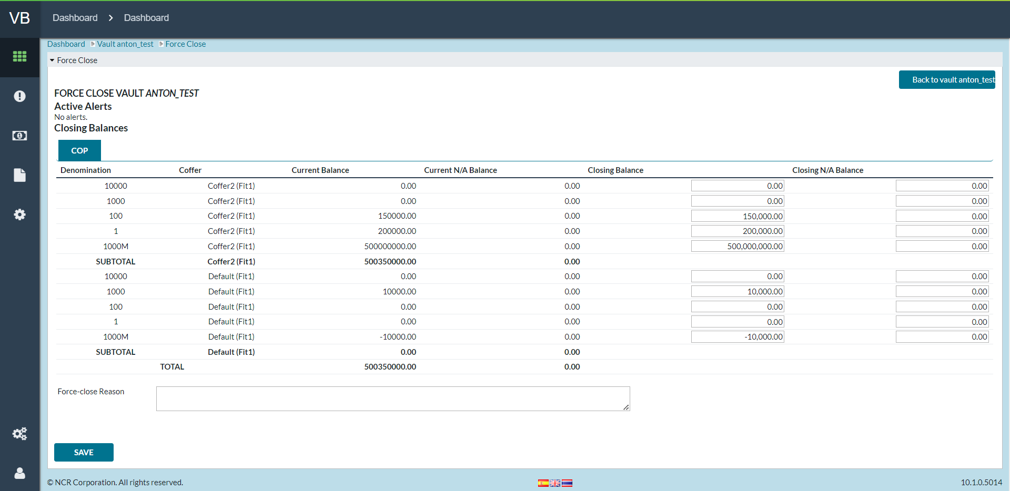

Return To: Coffer and Qualities

TABLE 15: FORCE-CLOSE FIELD DESCRIPTIONS

|  |  |
| --- | --- |
| Field | Description |
| **Closing Balance** | Total Closing Balance by Denomination and Coffer |
| **Closing N/A Balance** | Not Available Balance by Denomination and Coffer |
| **Force-close Reason** | Open text field for the VB user to enter the reason (why the balances were manually entered thus forcing a closing on the vault). |

*Return To:Coffer and Qualities*

## CASH QUALITIES

*Settings→Cash* Qualities navigates to a listing of all currently used cash qualities. Common qualities include **Fit, Normal, Unknown,** and **Soiled**. For usage inside Vault Balance, each quality may be assigned a custom name, but it must be equated to quality definitions in OptiCash and OptiVault for transactions from those applications to process correctly in OptiVLM – Vault Balance.

FIGURE 25: CASH QUALITIES SCREEN

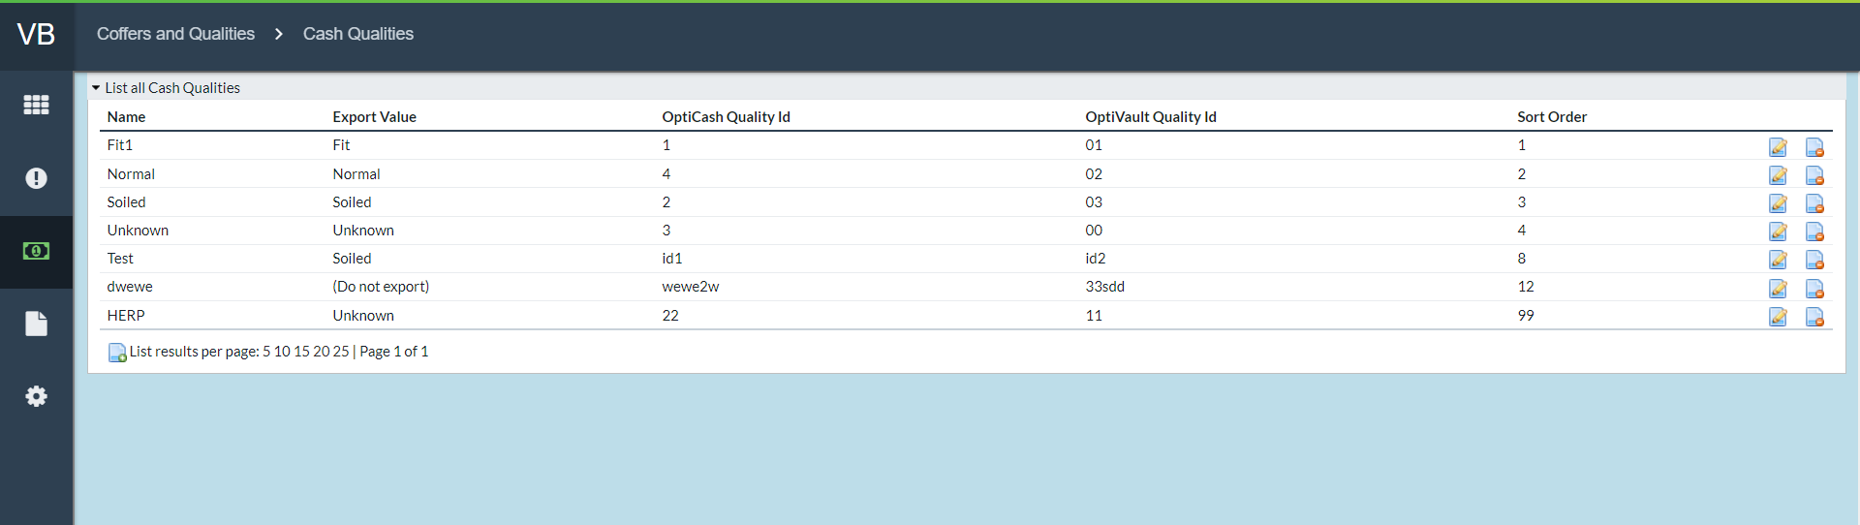

Return To: Coffer and Qualities

TABLE 20: CASH QUALITIES FIELD DESCRIPTIONS

|  |  |
| --- | --- |
| Field | Description |
| **Name** | User-assigned name for a quality to be used |
| Field | Description |
| **Export Value** | Each user-defined quality must be associated with one of the standard four qualities used by OptiVault when exported:   * Fit * Normal * Unknown * Soiled   (Do Not Export) for internal vault/institution usage and will not be associated with any of the four standard qualities for exporting purposes. |
| **OptiCash Quality ID** | OptiCash actions (primarily Orders) may refer to the quality of cash involved. This field specifies which quality in OptiCash is equivalent to this quality. |
| **OptiVault Quality ID** | OptiVault actions (primarily Orders) refer to the quality of cash involved. This field specifies which quality in OptiVault is equivalent to this quality. |
| **Sort Order** | The setting determines in what order the quality is listed inside of the Vault. The lowest number gives the highest priority and will be listed first. |

Return To:Coffer and Qualities

### CREATE NEW QUALITIES

By clicking on the **New Cash Quality** icon at the bottom of the *Settings→Cash Qualities* screen, the user will be navigated to the **Create New Cash Qualities** screen. For field, description see TABLE 20: CASH QUALITIES FIELD DESCRIPTIONS.



FIGURE 26: CREATE NEW CASH QUALITIES SCREEN

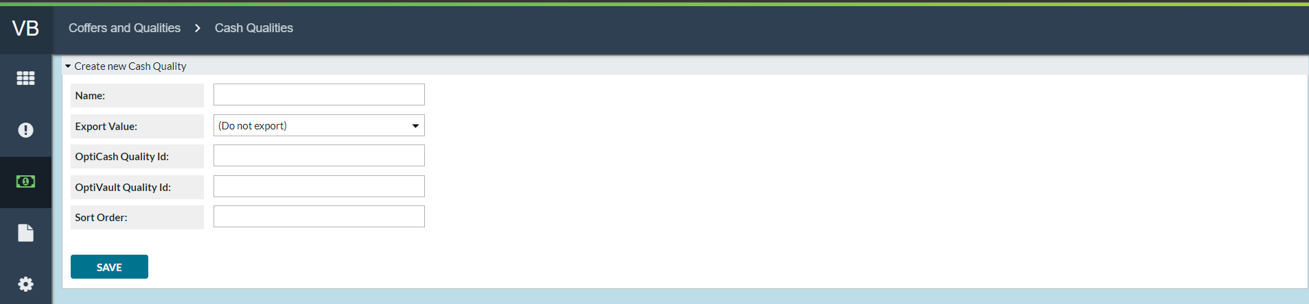

*Return To: Coffer and Qualities*

## CASH QUALITY MAP

*Settings→Cash* Quality Map provides access for defining how **Cash Qualities** will be used in OptiVLM – Vault Balance. **Cash Quality Map** is available to override the quality designation of cash in orders that may specify differently or specify no quality at all. If an entry is made here for a particular workflow, then all movements of cash in that way will be recorded against the balance of the specified quality. If no entry is made, then Vault Balance will record the movements against qualities specified elsewhere (usually in the order itself). **For example**, if a Branch Return order specifies that it has qualities “**Fit**” and “**Soiled**”, but the vault manager wishes to initially treat all Branch Returns as “**Unknown**” quality, then a Cash Quality Map entry would be used to say that Branch Returns are Unknown quality within Vault Balance.

FIGURE 27: CASH QUALITIES MAP SCREEN

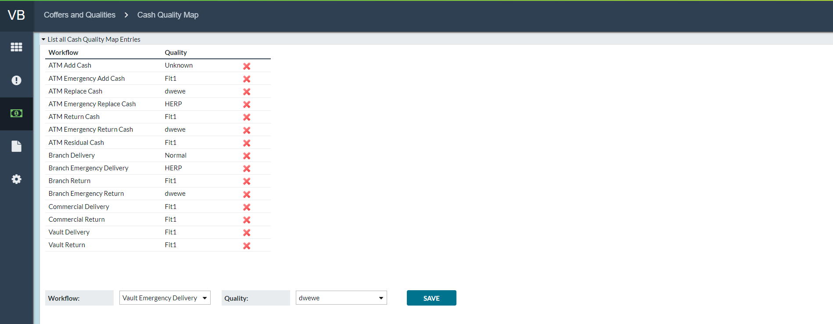

Return To:Coffer and Qualities

TABLE 21: CASH QUALITY MAP FIELD DESCRIPTIONS

|  |  |
| --- | --- |
| Field | Description |
| **Workflow** | A unique listing of each workflow that has been mapped to a particular Quality |
| **Quality** | A unique quality that has been mapped to a workflow. Different qualities can be mapped to multiple workflows. Workflows can only be mapped to a single Quality at any given time. |
|  | Removes the existing Workflow-to-Quality mapping |

*Return To: Coffer and Qualities*

### CREATE NEW CASH QUALITY

The bottom of the **Cash Quality** page provides the ability to map remaining and unmapped Workflows to Qualities. Users can select the **Workflow** from the appropriate dropdown, select the desired **Quality**, and click **SAVE**. The mapping will then be added to the Cash Quality Map listing.

FIGURE 28: CREATE A NEW CASH-QUALITY MAP

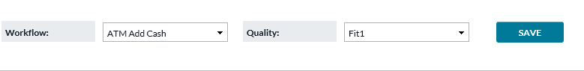

Return To: Coffer and Qualities

TABLE 22: CASH QUALITY MAP FIELD DESCRIPTIONS

|  |  |
| --- | --- |
| Field | Description |
| **Workflow** | A unique listing of each workflow that has been mapped to a particular Quality |
| **Quality** | A unique quality that has been mapped to a workflow. Different qualities can be mapped to multiple workflows. Workflows can only be mapped to a single Quality at any given time. |
| **Coffer** | Denotes the Coffer that the combination of Workflow and Quality has been mapped to |
|  | Removes the existing Coffer |

*Return To: Coffer and Qualities*

## COFFERS

*Settings→Coffers* provides a listing of all existing coffers. Coffers are unique mapping of **Workflow** to **Cash Quality** to facilitate financial institution tracking of cash by designations.

FIGURE 29: LIST ALL COFFERS SCREEN

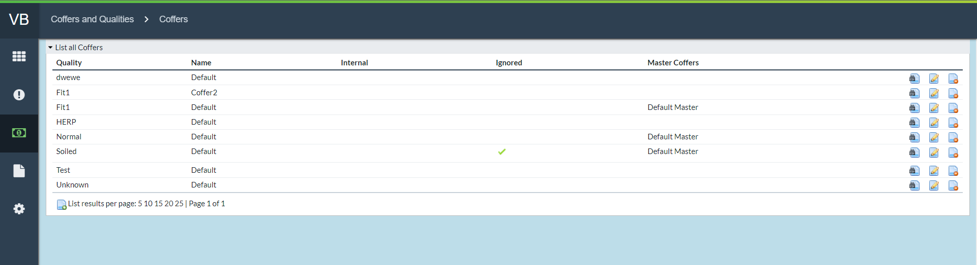

*Return To: Coffer and Qualities*

TABLE 23: LIST ALL COFFERS FIELD DEFINITIONS

|  |  |
| --- | --- |
| Field | Description |
| **Name** | Name of each uniquely defined Coffer |
| **Quality** | The cash quality that is assigned to the Coffer. |
| **Internal** | Check the box to designate if the Coffer is only used Internally. |
| **Ignored** | Check the box to designate if the Coffer is ignored when calculating the total on the Coffer Balance Page. Please note this change affects the total row only in the coffer balance page and PDF, not to any other balance pages or PDF. |
| **Master Coffer** | The name of Master Coffer that this Coffer belongs to. |

*Return To: Coffer and Qualities*

### CREATE NEW COFFER

By clicking on the **New Coffer** icon at the bottom of the *Settings→Coffers* screen, the user will be navigated to the **Create New Coffer** screen. For field description see TABLE 20: CASH QUALITIES FIELD DESCRIPTIONS



FIGURE 30: CREATE A NEW COFFER

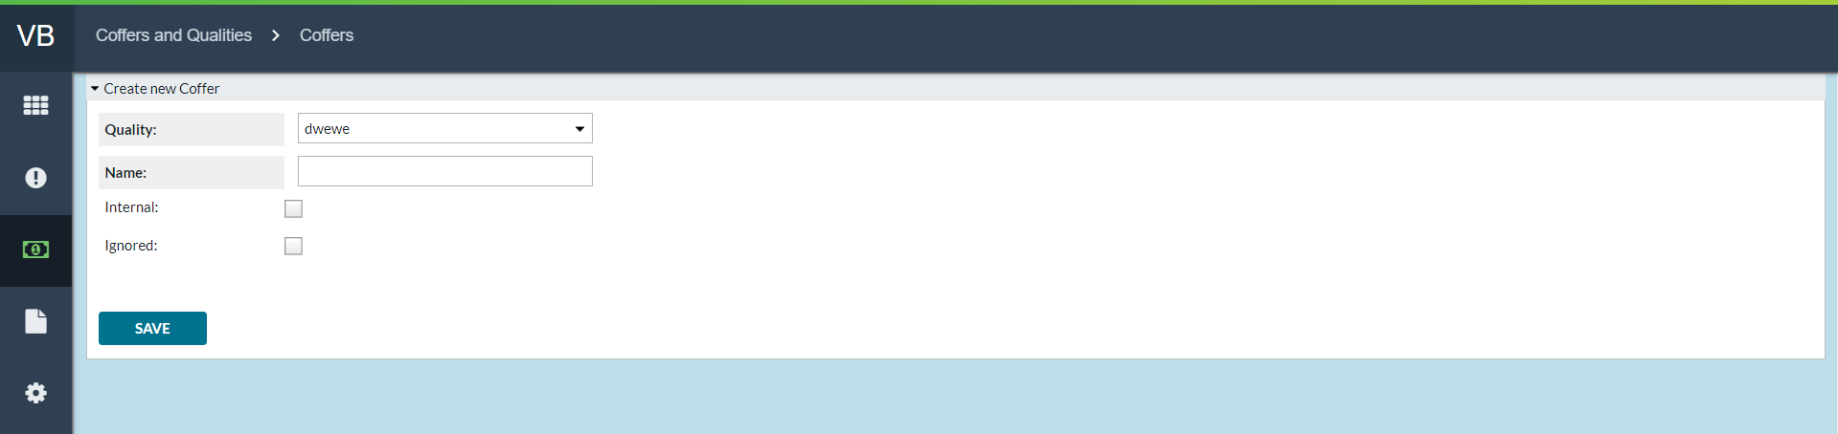

*Return To: Coffer and Qualities*

## BALANCE ACTION MAP

*Settings→Balance* Action Map defines how Vault Balance will treat and reconcile cash movements. Vault Balance handles each workflow separately, and it also provides the ability to break down each workflow into its sub-parts. The Balance Action Map defines how Vault Balance should modify balances at each point in the chain.

A workflow consists of States that an order can be in at a given time, and Tasks are actions that may be performed from a given State. In the example diagram below, black text in bubbles is **States**, while red text next to arrows represents **Tasks**. For instance, Orders can be ‘**Ordered**’ by OptiSuite users but a supervisor has to ‘**Approve**’ the order before it goes on to be transmitted to the carrier.

**Workflows can be uniquely defined for order types:** ATM Add, ATM Replace, ATM Emergency Add, ATM Emergency Replace, Branch Delivery, Branch Return, Branch Emergency Delivery, Branch Emergency Return, Commercial Client Delivery, Commercial Client Return, Vault Delivery, Vault Return, Emergency Vault Delivery, Emergency Vault Return, ATM Return Cash and ATM Emergency Return.

Additionally, a Balance Action Map entry is necessary when ATM Residual information is input into OptiCash (this does not follow a workflow).

FIGURE 33: EXAMPLE OF AN ORDER WORKFLOW REQUIRING A BALANCE ACTION MAP

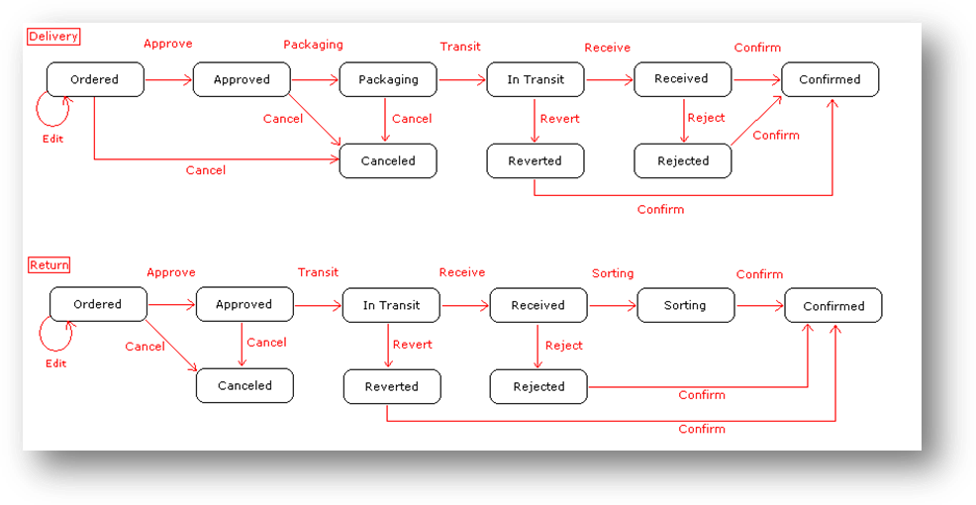

*Return To: Coffer and Qualities*

The Balance Action Map in Vault Balance determines what action will be taken with the cash at each task occurrence. **For example**, when a vault holds an order and it goes to state “**In Transit**” the Admin user may determine that at that point the Balance Action should be to *subtract* the In Transit amount from the vault balance.

FIGURE 34: BALANCE ACTION MAP SCREEN

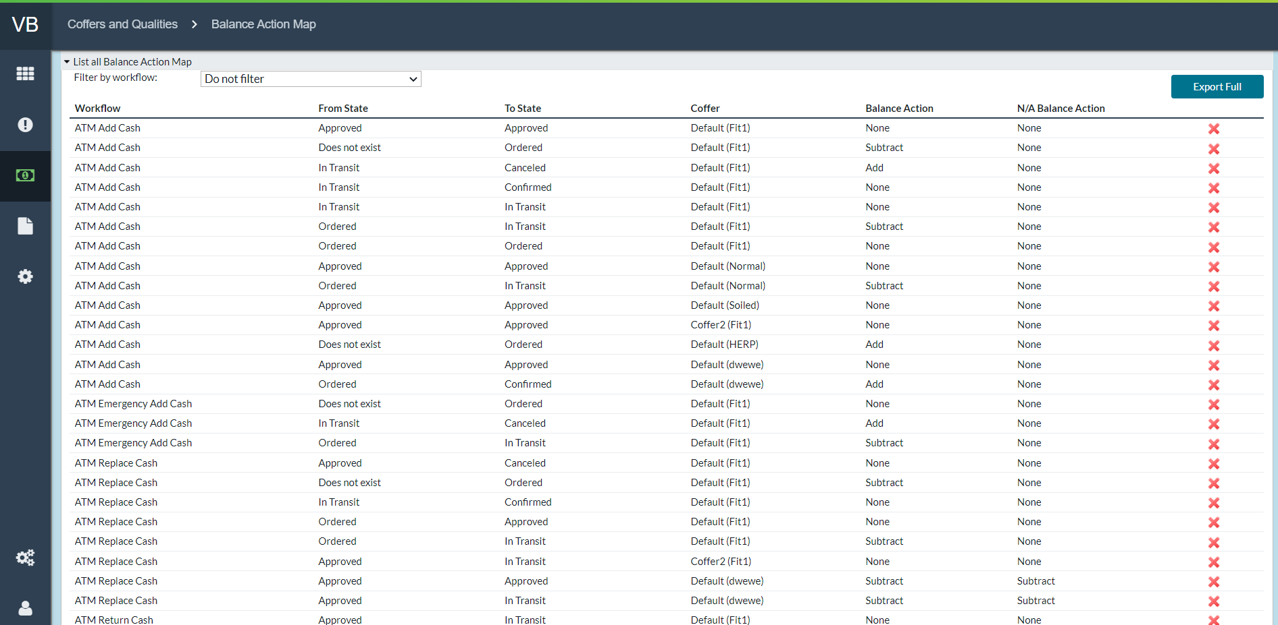

Return To: Coffer and Qualities

TABLE 24: BALANCE ACTION MAP FIELD DESCRIPTIONS

|  |  |
| --- | --- |
| Field | Description |
| **Filter by Workflow** | Allows Users to filter the listing of Balance Action Map entries according to workflow. |
| **Workflow** | Displays the workflow to which the Balance Action will apply. |
| **From State** | Shows the beginning state for the action being defined. Valid States will vary by institution. |
| **To State** | Shows the final state for the action being defined. Valid States will vary by institution. |
| **Export Full** | This option exports all of the Balance Action Maps into a CSV file. This allows the user to edit the file to add/remove Balance Action maps and then reload it into Vault Balance, making it easier to do multiple changes at once. |
| **Coffer** | If a Coffer has been defined for a particular Workflow/Quality combination, it will be denoted in this column. |
| **Balance Action** | Determines what should be done with the Vault Balance amount. Add, Subtract, or None. Some state changes may increase (Add) or decrease (Subtract) the balance whereas others would trigger no change (None). |
| **N/A Balance Action** | Determines what should be done with the Vault Balance amount. Add, Subtract, or None. Some state changes may increase (Add) or decrease (Subtract) the balance whereas others would trigger no change (None). |
| **Import Balance**  **Action Map** | Allows the user to upload the desired Balance Action Maps to Vault Balance in CSV format.  **Note**: The contents of the file will overwrite what is currently there, rather than simply adding the contents of the file. |

Return To: Coffer and Qualities

### CREATE A NEW BALANCE ACTION MAP ENTRY

New Balance Action Map entries may be established by filling in the fields in the blue section at the bottom of the **Balance Action Map** screen and clicking **SAVE**.

FIGURE 35: CREATE NEW BALANCE ACTION MAPS

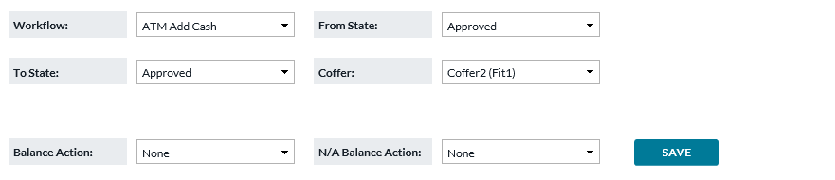

*Return To: Coffer and Qualities*

# Logs

## SYSTEM EVENT LOG

*Settings→System* Event Log provides access to tracking system events. Often these are generated as a result of the real-time interaction of Vault Balance with OptiSuite. User modifications to balances are also recorded here.

FIGURE 36: SYSTEM EVENT LOG SCREEN

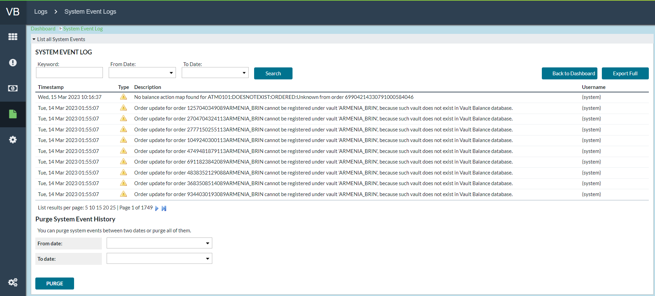

*Return To: Logs*

TABLE 25: SYSTEM EVENT LOG FIELD DESCRIPTIONS

|  |  |
| --- | --- |
| Field | Description |
| **Timestamp** | Shows system generated Timestamp for when each item occurred and generated a log entry. |
| **Type** | Icons show the nature of the log entry. Three icons may occur:    Denotes the entry is merely informational    Denotes an occurrence that may require user investigation/action    Denotes a warning associated with an error such as there is not a proper **Balance Action Map** associated with the occurrence that generated the Log. User interaction will be necessary |
| **Description** | Lists the actual log definition line describing the occurrence and the associated cashpoints |
| **Username** | Will show the Vault Balance user that has interacted with or resolved the occurrence. |
| **Keyword** | Allows the user to search the **Event Log** and return only those results that contain the keyword. Useful for searching events tied to a specific Order Reference number. |
| **From and To Dates** | Allows the user to search the **Event Log** entries by Date. |
| **Purge System Event History** | Allows the user to purge the Logs in the specified Date range, or delete all Logs by leaving the fields blank. |

*Return To: Logs*

|  |  |
| --- | --- |
|  |  |
|  |  |
|  |  |
|  |  |
|  |  |
|  |  |



### TRANSACTIONS LIST

Totals and Sub-totals on the **Vault Details** screen are hyperlinked. The hyperlinks navigate the user to the **Transactions List** page which details all the individual transactions that combine to make the Total or Sub-total. Users may see the same order occur multiple times on the transaction list as they progress through the workflow.

FIGURE 7: VAULT DETAILS TRANSACTION LIST

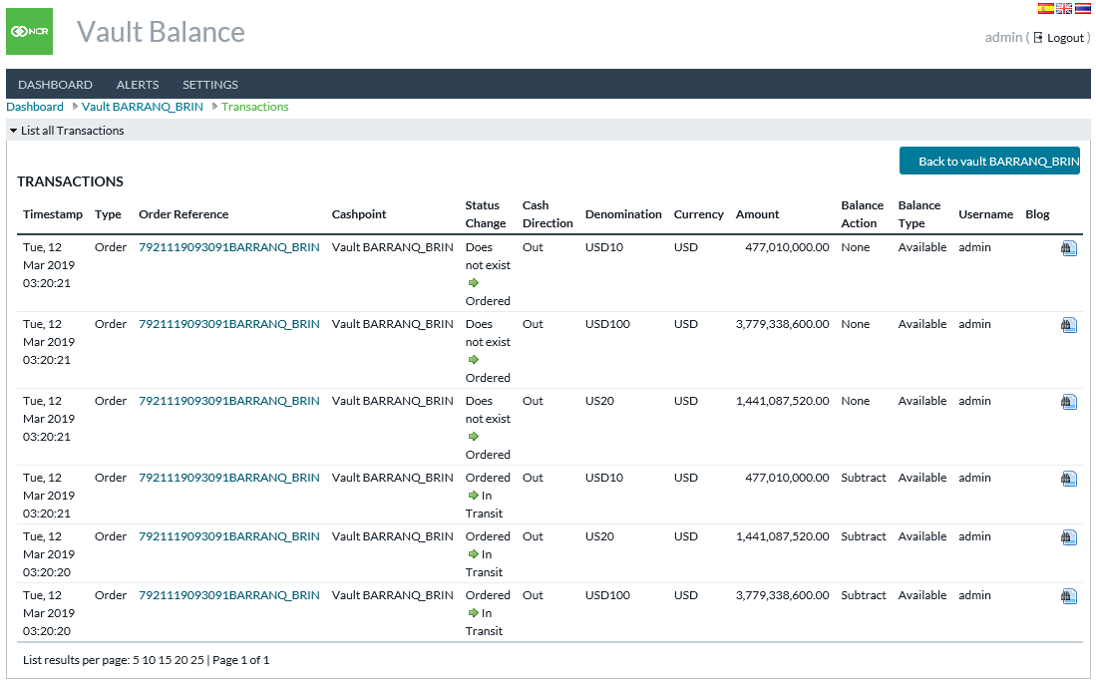

Return To: Logs

TABLE 11: VAULT TRANSACTION LIST FIELD DEFINITIONS

|  |  |
| --- | --- |
| Field | Description |
| **Timestamp** | Date and time the **Transaction** was entered into the system |
| **Type** | Order, Adjustment, etc. |
| **Order Reference** | Unique order reference number. This field is hyperlinked to navigate to the “**Show Opti Order**” screen |
| **Cashpoint** | The Cashpoint ID of the order source/destination |
| **Status Change** | Shows both the prior and current workflow status of each order |
| **Cash Direction** | Cash flow direction relative to the Vault. |
| **Denomination** | Denomination of this record |
| **Currency** | Currency of this record |
| **Amount** | Transaction amount |
| **Balance Action** | The effect, if any, this transaction had on the vault balance: Add, Subtract, or None. |
| **Username** | Username of the user who initiated the transaction |
| **Blog** | Field showing OptiSuite Blog details associated with the transaction |
|  | Navigates to the Show Transaction field which lists unique details for the transaction (See FIGURE 8: SHOW TRANSACTION SCREEN) |
| **Balance Type** | Indicates whether this transaction affects the Available or Unavailable balance. |
| **Order**  **(Show Transaction screen only)** | Same as the Order Reference number defined above |
| **Cashpoint Type**  **(Show Transaction screen only)** | Cashpoint type of the source/destination of the order (ATM, Branch, Vault, Internal or Commercial) |
| **Quality**  **(Show Transaction screen only)** | Cash quality designated for the Transaction. |

Return To: Logs

FIGURE 8: SHOW TRANSACTION SCREEN

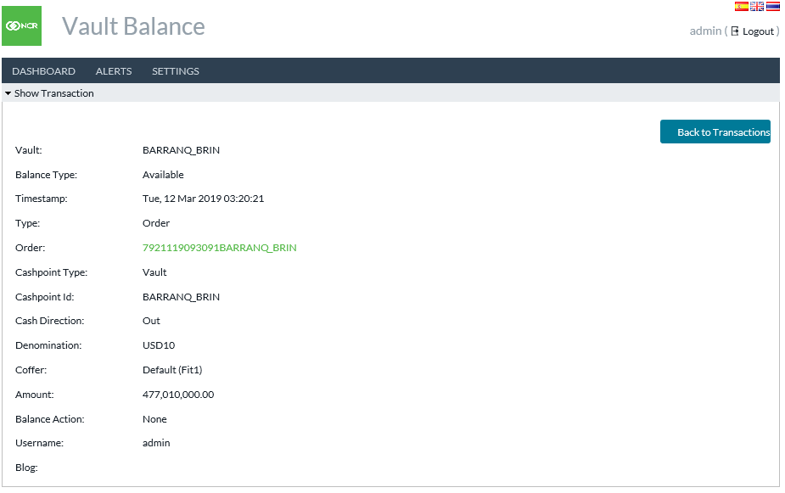

Return To: Logs

### SHOW OPTI ORDER SCREEN

The hyperlinked Order Reference number on the **Transaction List** screen and the hyperlinked **Order field** on the **Show Transaction** screen both navigate to the **Show Opti Order** screen. This screen shows detailed information about each unique order.

FIGURE 9: SHOW OPTI ORDER SCREEN

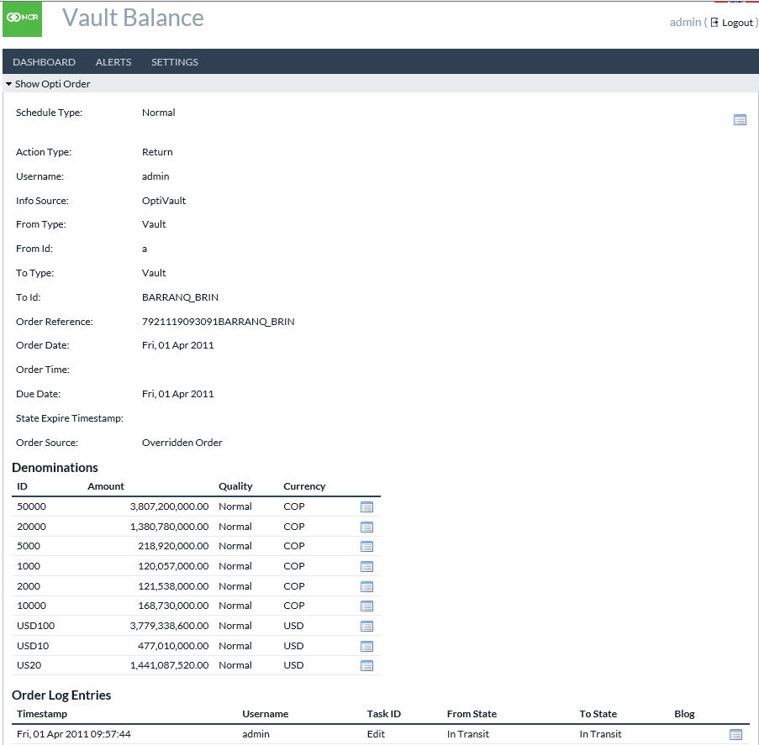

Return To: Logs

TABLE 12: VAULT TRANSACTION LIST FIELD DEFINITIONS

|  |  |
| --- | --- |
| Field | Description |
| **Schedule Type** | **Type of order:** Normal/Planned or Emergency/Unplanned |
| **Action Type** | **Type of order:** Delivery, Return, Add Cash to ATM, etc. |
| **Username** | Username of the person who entered the order |
| **Info Source** | OptiCash or OptiVault |
| **From Type** | Type of cashpoint the cash will originate in; Vault, Branch, ATM, or Commercial |
| **From ID** | Unique cashpoint ID of the “**From**” location |
| **To Type** | Type of cashpoint the cash will go to; Vault, Branch, ATM, or Commercial |
| **To ID** | Unique cashpoint ID of the “**To**” location |
| **Order Reference** | Unique OptiSuite reference number for the order |
| **Order Date** | Date stamp of order origination |
| **Order Time** | Timestamp of order origination |
| **Due Date** | Date stamp of order due date |
| **State Expire Timestamp** | Time/Date current Workflow state will Expire |
| **Order Source** | Manual, Auto-Commit Recommendation, etc. |
| **Denomination ID** | Denomination ID of each denomination in the order |
| **Amount** | Total amount by currency, denomination, and quality |
| **Quality** | Note quality of each denomination/currency |
| **Currency** | Currency ISO code for each denomination in the order |
| **Order Log Entries Timestamp** | Timestamp of each workflow action performed to the order that occurs in the Log |
| **Username** | Username of the person who performed each unique action |
| **Task ID** | Each workflow task that has occurred in reference to the unique order |
| **From State** | Each workflow task moves an order from one Workflow State to another. “**From state**” is the original state in each task |
| **To State** | Each workflow task moves an order from one Workflow State to another. “**To state**” is the state resulting from each task action |
| **Blog** | Blog messages associated with each task occurrence. |

Return To: Logs



### BALANCE HISTORY

The Balance History screen provides a historical view of balances for previous periods. Clicking on one of the hyperlinked dates loads a Vault Details screen with the balance details for the selected period.

FIGURE 11: BALANCE HISTORY SCREEN

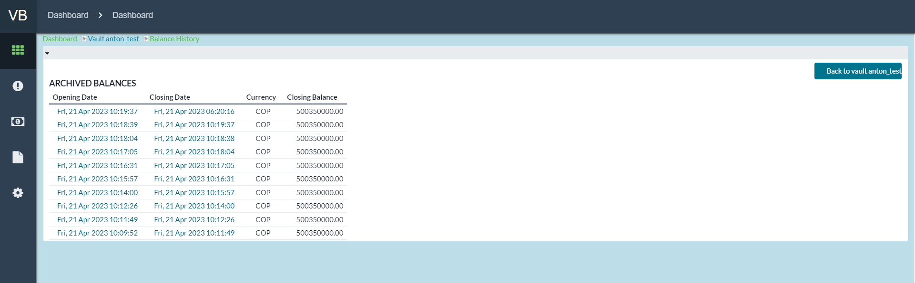

Return To: Logs

|  |  |
| --- | --- |
|  |  |
|  |  |
|  |  |
|  |  |
|  |  |
|  |  |



# SETTINGS

The settings menu is a gateway for controlling the parameters and settings that modify the various functions of OptiVLM – Vault Balance.

**Note**: Settings items are only available to the Admin user.

FIGURE 14: SETTINGS MENU

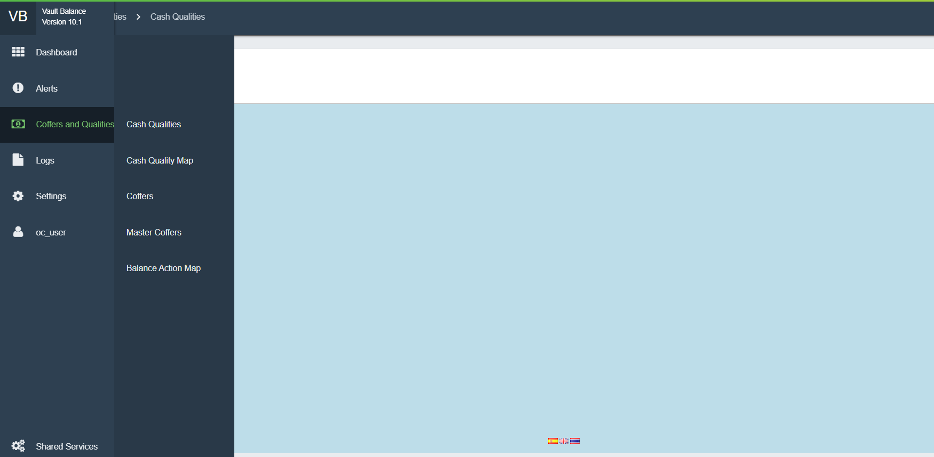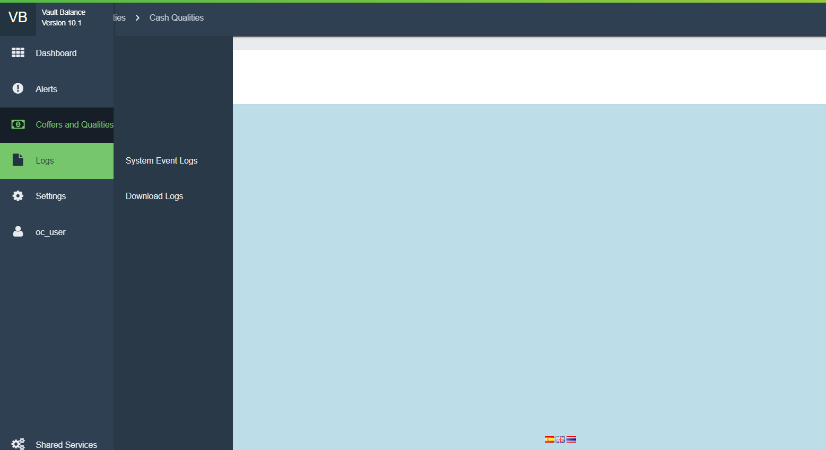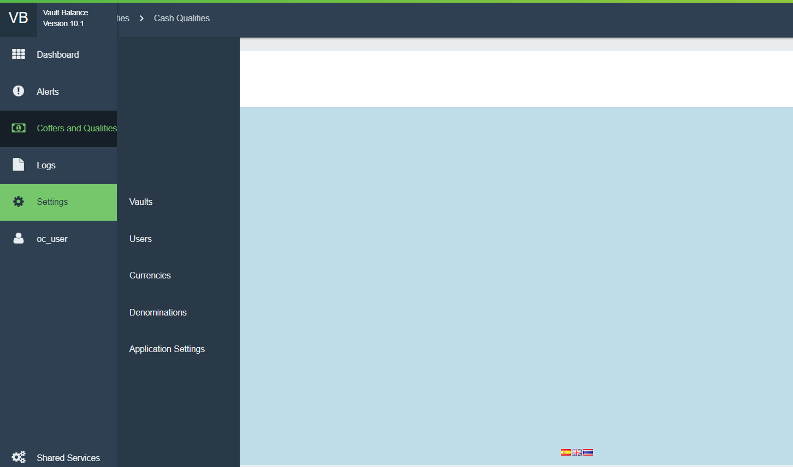

Return To: SETTINGS

## VAULTS

*Settings→Vaults* navigates to a listing of all currently established vaults. Balances will be tracked for these vaults.

FIGURE 15: VAULTS SCREEN

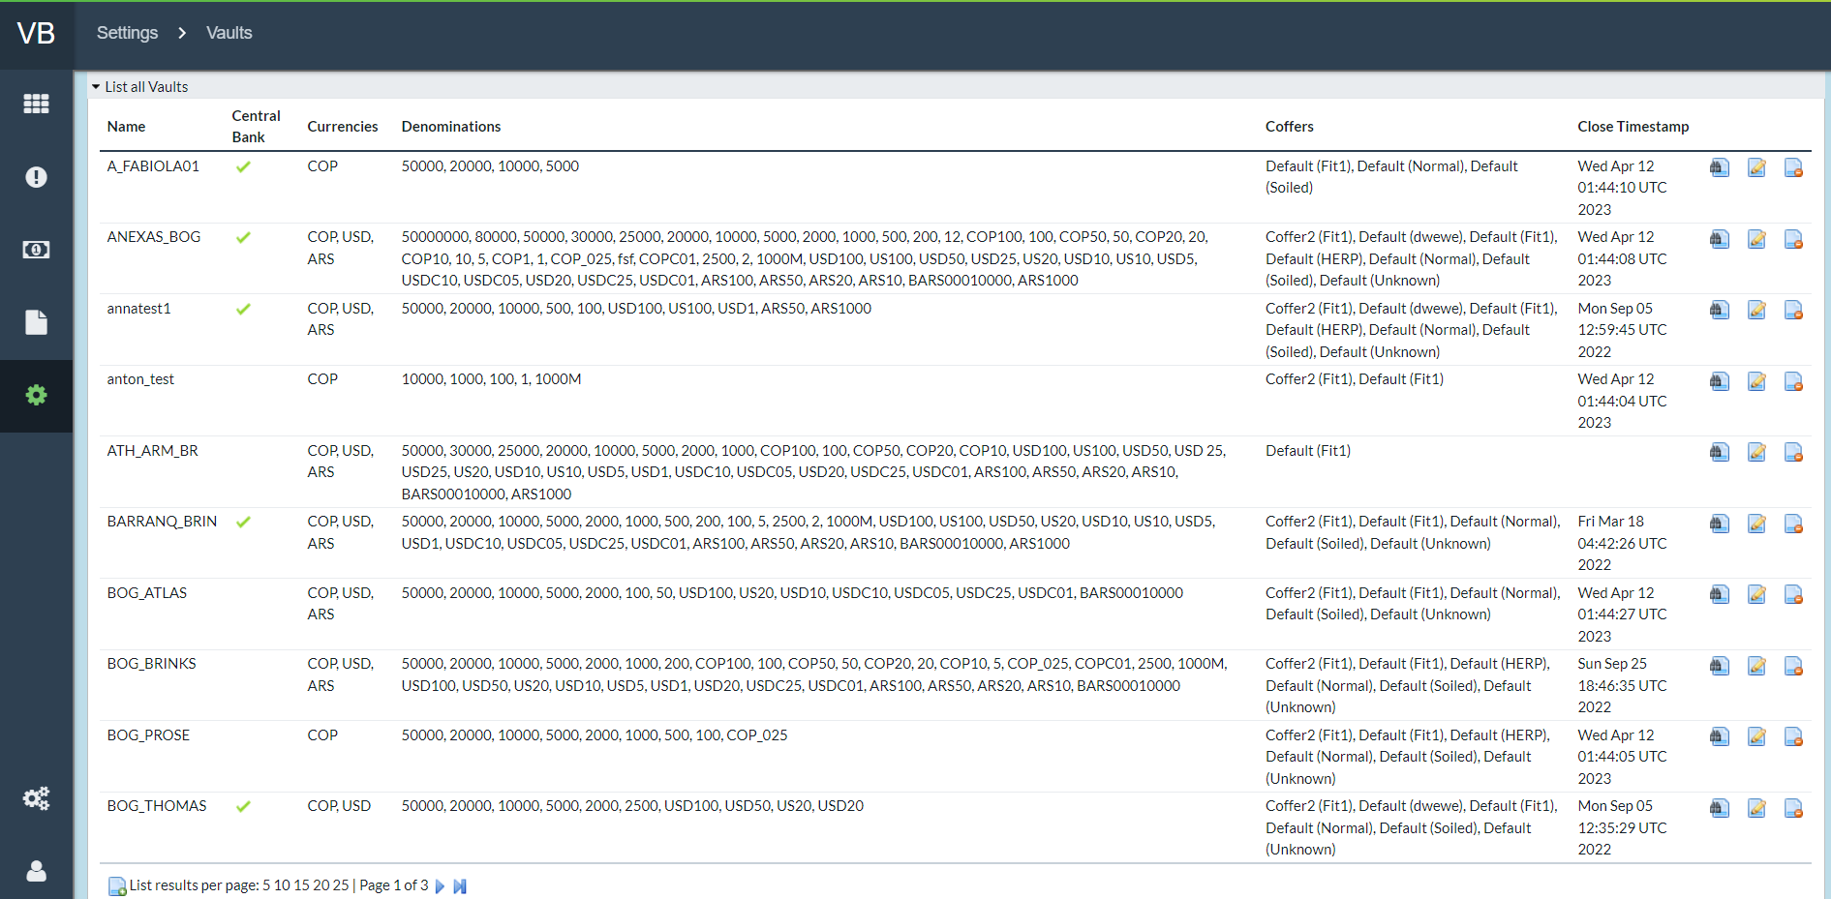

Return To: SETTINGS

TABLE : VAULT SCREEN

|  |  |
| --- | --- |
| Field | Description |
| **Central Bank** | Yes or No: This vault represents a Central Bank location. If yes, transactions to/from this vault will be marked in the Central Bank activity category, instead of with other vault transactions. |
| **Currencies** | Displays the Currencies that are assigned to the Vault |
| **Denominations** | Displays the Denominations that are assigned to the Vault |
| **Coffers** | Displays the Coffers that are available to the Vault |
| **Close Timestamp** | The timestamp of the last time the Vault was closed |

Return To: SETTINGS

### CREATE NEW VAULTS

By clicking on the **New Vault** icon at the bottom of the *Settings->Vaults* page, new vaults can be created. Only the name is required. OptiVLM - Vault Balance interacts with OptiSuite and necessary vault definitions are defined in OptiVault. To apply actions in OptiSuite to this vault, the name entered here must match the IDs of the vault as it is entered both in OptiVault and OptiCash (depot). In addition to entering a Name, the user is also able to assign Currencies, Denominations and Coffers to the Vault using checkboxes.



FIGURE 16: CREATE NEW VAULT SCREEN

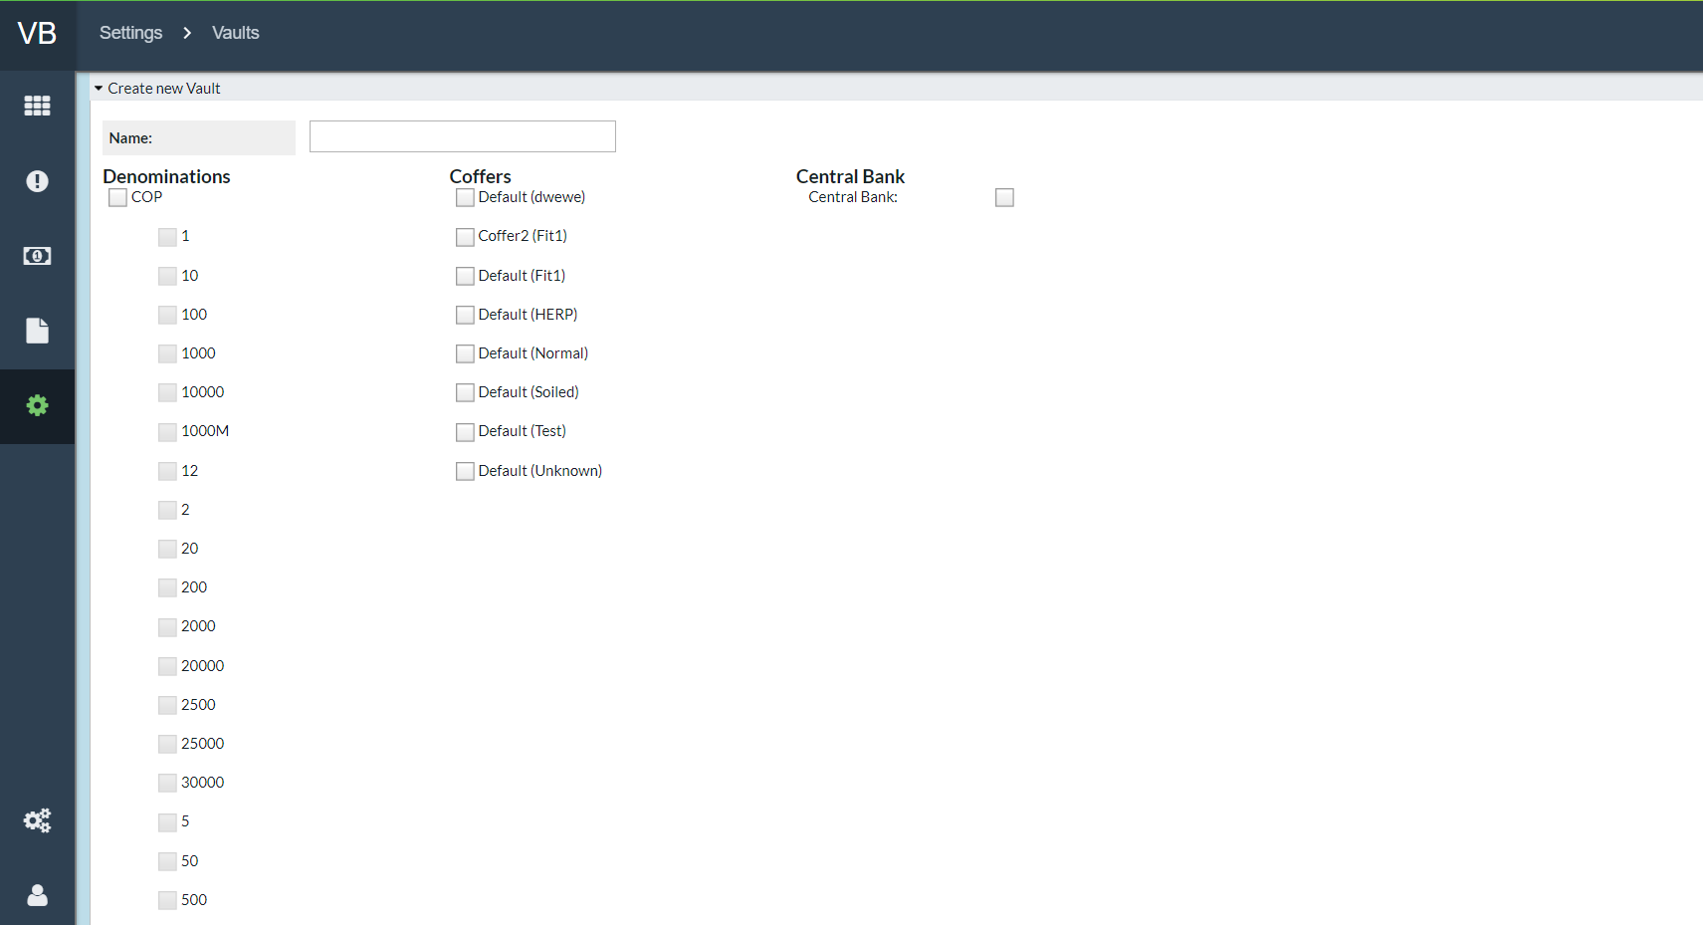

Return To: *SETTINGS*

## MASTER COFFERS

Master Coffer is a way of grouping order amounts from multiple qualities/coffers into a single container. By clicking on the **New Coffer** icon at the bottom of the *Settings→Master Coffer* screen, the user will be navigated to the **Create New Master Coffer** screen.



FIGURE : MASTER COFFERS

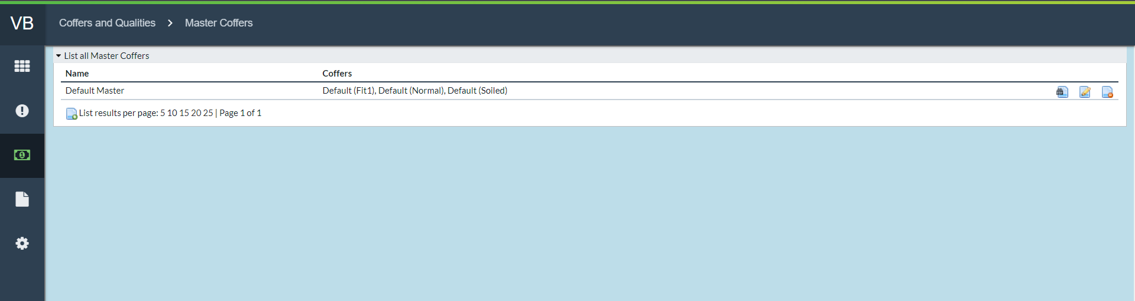

FIGURE : MASTER COFFER CREATION

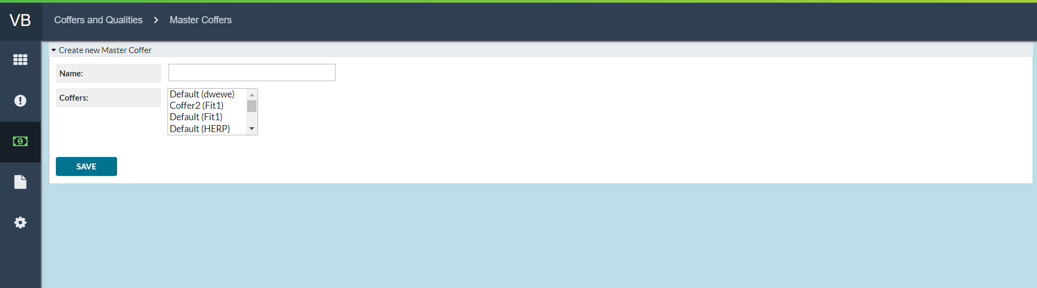

Return To: SETTINGS

### USERS

*Settings→Users* navigate to a listing of all currently established Users.

FIGURE 19: USER SCREEN

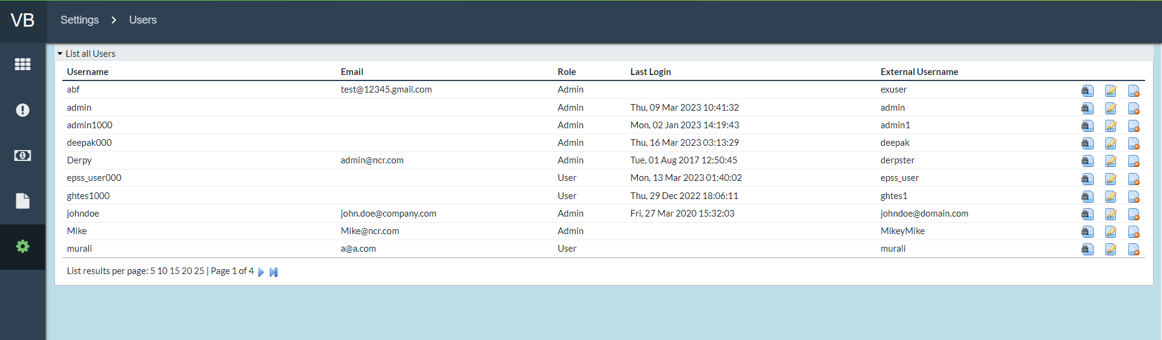

TABLE 17: USERS FIELD DESCRIPTIONS

|  |  |
| --- | --- |
| Field | Description |
| **Username** | Unique Username assigned per user |
| **Email** | Email account associated with each username |
| **Role** | Shows the assigned roles for the username.   * Admin * User   **Note**: Choosing the **'Admin'** role will grant access to Settings functions and all vaults. Choosing the **'User'** role will limit access to selected vault(s) and prevent Settings manipulation. |
| **Last Login** | Shows the last date/time the user logged into Vault Balance |
| **External Username** | When using External Authentication for login purposes, the external username associated with the account will be displayed. |
| **Vault Access**  **Add A Vault**  **(new user creation only)** | When creating users, Administrators will grant access to specific vault(s) using the dropdown in the **New User Creation Vault Access** screen. |
| **Allow Internal Adjustments** | Yes/No radio button to allow the created user to do Internal Adjustments. |
| **Allow Quick Adjustments** | Yes/No radio button to allow the user to do Quick Adjustments. |

Return To: SETTINGS

FIGURE 20: CREATE NEW USER SCREEN

*Return To: SETTINGS*

## CURRENCIES

*Settings→Currencies* provides access for listing the Currencies that are handled in OptiSuite and will be tracked and balanced in Vault Balance. Users may also prioritize the currencies in terms of processing and may denote a “**Main Currency**”.

FIGURE 21: CURRENCIES SCREEN

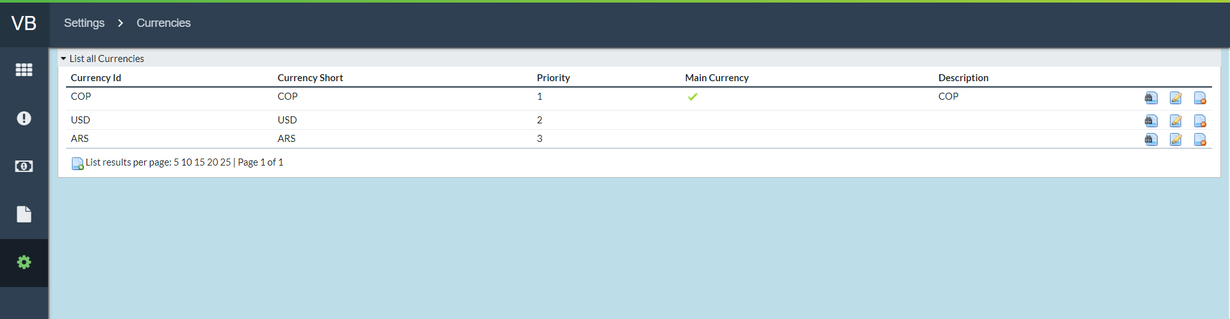

Return To: SETTINGS

TABLE 18: CURRENCIES FIELD DESCRIPTIONS

|  |  |
| --- | --- |
| Field | Description |
| **Currency ID** | The 3-character ID associated with each currency and as defined in OptiSuite |
| **Currency Short** | Short name for each currency |
| **Description** | Description of the currency |
| **Main Currency** | Denotes the primary currency and is most important for processing. Denoted with the icon: |
| **Priority** | A unique priority for the currency. The priority of the currencies defines the main/lesser relationship for the currencies dispensed at the cashpoints. The priority of the currency decreases as the numeric value of the priority increases. So priority value of 1 is the highest and will be defined for the main currency. |

Return To: SETTINGS

### CREATE NEW CURRENCIES

By clicking on the **New Currency** icon at the bottom of the *Settings→Currencies* screen, the user will navigate to the **Create New Currency** Screen. Users can select from the pre-filled dropdown of Currency IDs, fill in the other fields and click **SAVE**. For field definitions see TABLE 18: CURRENCIES FIELD DESCRIPTIONS



FIGURE 22: CREATE NEW CURRENCY SCREEN

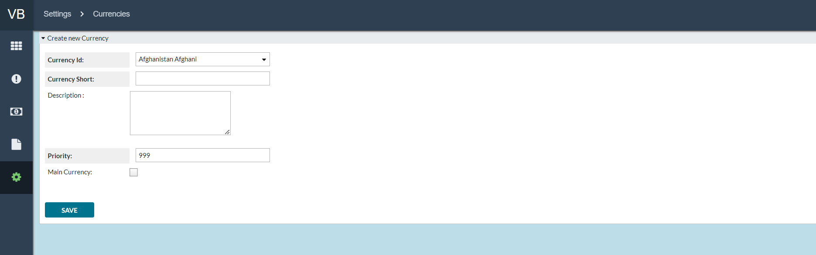

Return To: SETTINGS

## DENOMINATIONS

*Settings→Denominations* provides access for defining the denominations that will be tracked and balanced via Vault Balance.

FIGURE 23: DENOMINATIONS SCREEN

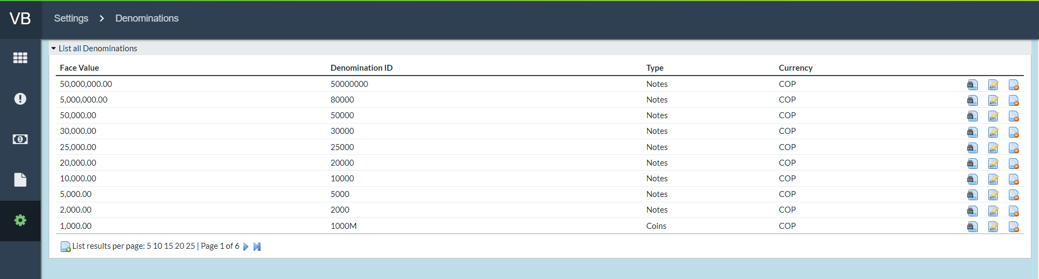

Return To: SETTINGS

TABLE 19: Denominations Field Descriptions

|  |  |
| --- | --- |
| Field | Description |
| **Face Value** | Defines the value of each denomination. **For example**, A 1-USD note would have a 1 value for **Face Value** |
| **Denomination ID** | Sets the denomination ID used by Vault Balance. This field should be coordinated with definitions throughout OptiSuite. |
| **Type** | Denotes either Note or Coin |
| **Currency** | Selects the Currency with which the Denomination is associated. |

Return To: SETTINGS

### CREATE NEW DENOMINATIONS

By clicking on the **New Denomination** icon at the bottom of the *Settings→Denominations* screen, the user will be navigated to the **Create New Denominations** screen. Users will have to fill in the fields, select the appropriate values in the dropdown menus, and click **SAVE**. For field definitions see TABLE 19: Denominations Field Descriptions.



FIGURE 24: CREATE NEW DENOMINATIONS SCREEN

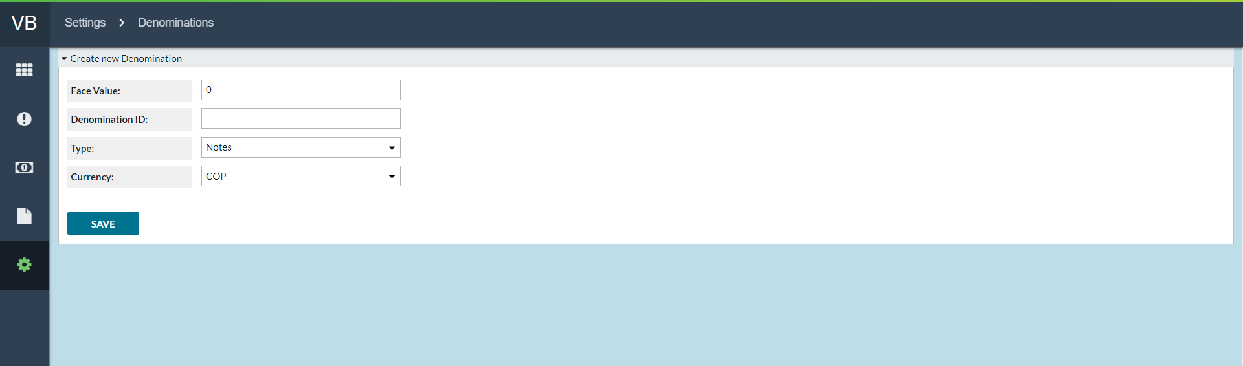

Return To: SETTINGS















### MASTER COFFER

Master Coffer is a way of grouping order amounts from multiple qualities/coffers into a single container. By clicking on the **New Coffer** icon at the bottom of the *Settings→Master* Coffer screen, the user will be navigated to the **Create New Master Coffer** screen.



FIGURE : MASTER COFFER

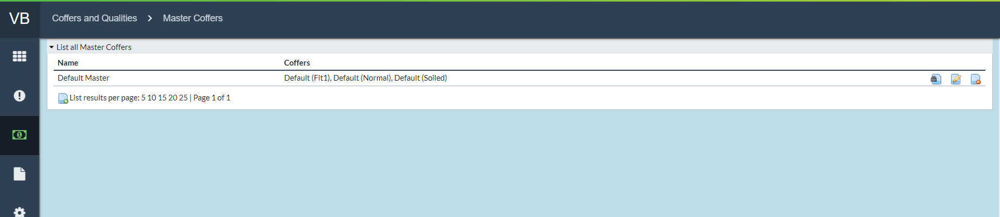

FIGURE : MASTER COFFER CREATION

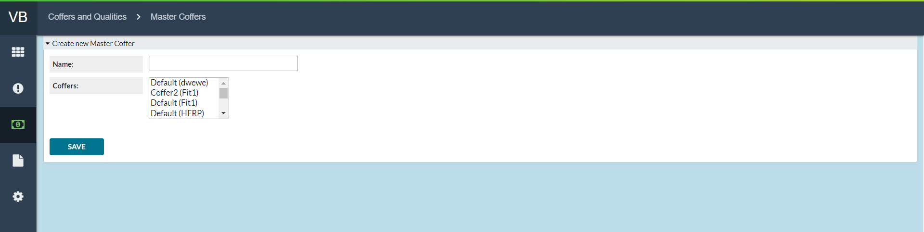







## APPLICATION SETTINGS

FIGURE : APPLICATION SETTINGS

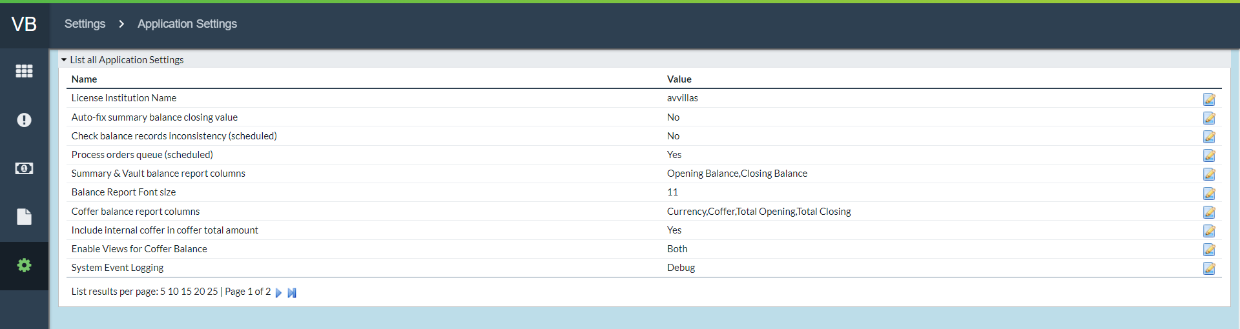

TABLE : APPLICATION SETTINGS DESCRIPTIONS

|  |  |
| --- | --- |
| Field | Description |
| **License Institution Name** | Displays the Institution name that the product is licensed to. |
| **Balance Report Font Size** | Allows the user to set the Font size on the PDF version of the **Balance Report** to make things more readable if the report contains numerous or few columns. |
| **Auto-fix summary Balance Closing Value** | Turn on a process that will ensure that the values in the **Summary Balance** page and **Balance** pages will be consistent, as problems could arise if there is a large amount of data change at the same time. |
| **Check Balance records inconsistency (scheduled)** | Checks the balances and summary balances for inconsistencies when checked. If it is checked it will be constantly checked, uncheck it to stop the process. |
| **Process orders queue (scheduled)** | Check to have VB constantly updated with orders from OptiSuites. Unchecking this will allow the user to stop accepting orders/updates in VB until the option is checked again. |
| **Summary & Vault balance report columns** | Allows the user to choose which columns will be outputted in the export files. |
| **Coffer Balance report columns** | Allows the user to choose which columns will be outputted when exporting Coffer Balances. |
| **Include internal coffer in coffer total amount** | Yes/No option to choose whether or not Coffers marked as Internal will be included in the Coffer total. |
| **Enable Views for Coffer Balance** | Drop down box allows the user to choose if the Coffer Balance, Master Coffer Balance or Both are enabled in the application. |
| **System Event Logging** | Allows the user to choose the level of logging the application will generate. Info, Debug, Warning or Error. |

Return To: SETTINGS

# DATABASE UPGRADES

This page will exhibit the SQL Queries for upgrades, if required, and enable the user to verify whether an upgrade is necessary.

FIGURE 38: DATABASE UPGRADE SCREEN

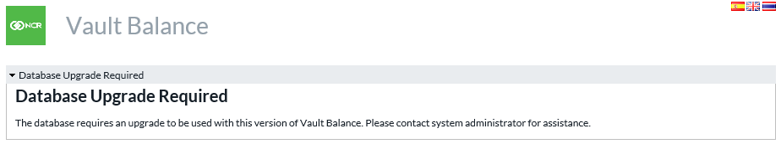

Return To:SETTINGS

# ALERTS

*Settings*>*Alerts* is a gateway menu to view either **Active Alerts** or **Alerts History.** There are two types of Alerts: **Vault** and **Order**.

**Vault alerts** pertain to issues with the vault such as Negative Vault Balance which would likely point to a timing or bookkeeping issue.

**Order alerts** pertain to orders and their statuses.

## ACTIVE ALERTS

FIGURE 39: ACTIVE ALERTS SCREEN

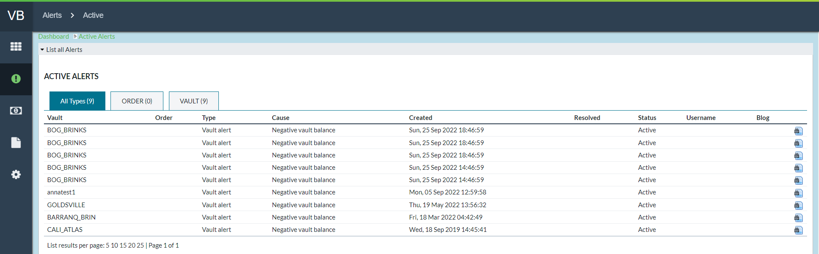

Return to: Alerts

TABLE 27: Alerts Field Descriptions

|  |  |
| --- | --- |
| Field | Description |
| **All Types (tab)** | Shows All Alerts regardless of the type |
| **Order (tab)** | Shows Alerts associated with Orders |
| **Vault (tab)** | Shows Alerts associated with Vaults |
| **Vault** | Vault for which the alert has occurred |
| **Order** | Order ID number if the alert is associated with an order |
| **Type** | Type of Alert: **Vault** or **Order** |
| **Cause** | Reason for Alert occurrence |
| **Created** | Timestamp for generation of Alert |
| **Resolved** | Timestamp for resolution of the cause of the Alert |
| **Status** | Current Status; Active, Ignored or Resolved |
| **Username** | The username of the user investigating or has resolved the Alert |
| **Blog** | Blog of notes entered by user during investigation and resolution of Alerts. |

Return to: Alerts

## ALERTS HISTORY

The Alert History screen shows the same information as the **Active Alerts** screen but limits its returned information to only those with Resolved status.

FIGURE 40: ALERTS HISTORY SCREEN

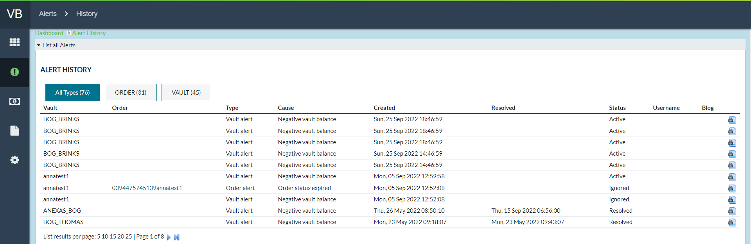

CXBanking, OptiVLM Vault Balance 10.1, User Reference Guide

April 2023

www.ncr.com